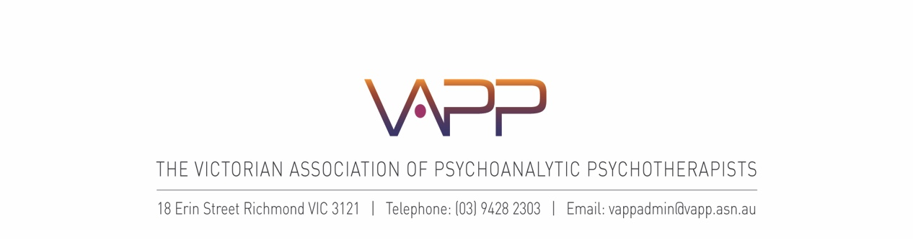

**INTRODUCTORY COURSE APPLICATION FORM 2025**

**NAME: ………………………………………………………………………………………………………...**

**ADDRESS: …………………………………………………………………………………………………...**

**……………………………………………..........................................................Postcode……………...**

**PHONE: (Work)……………………………… (Mobile)……………………………………………............**

**EMAIL: ……………………………………………………………………………………………….............**

**QUALIFICATIONS:**

**…………………………………………………………………………….…………….................................**

**…………………………………………………………………………………………..................................**

**PROFESSIONAL MEMBERSHIPS:**

**…………………………………………………………………………….…………….................................**

**…………………………………………………………………………………………..................................**

**PREVIOUS RELEVANT EMPLOYMENT:**

**…………………………………………………………………………….…………….................................**

**…………………………………………………………………………………………..................................**

**CLINICAL EXPERIENCE:**

**…………………………………………………………………………….…………….................................**

**…………………………………………………………………………………………..................................**

**………………………………………………………………………………………………………………….**

**………………………………………………………………………………………………………………….**

**………………………………………………………………………………………………………………….**

**CURRENT EMPLOYER: Nature of Work**

**……………………………………………………………………………………….....................................**

**……………………………………………………………………………………….…………………………**

**………………………………………………………………………………………………………………….**

**………………………………………………………………………………………………………………….**

**EXPERIENCE OF PSYCHODYNAMIC/ PSYCHOANALYTIC THEORY OR PRACTICE**

**For example reading group, supervision, seminars, personal psychotherapy**

**…………………………………………………………………………….…………….................................**

**…………………………………………………………………………………………..................................**

**………………………………………………………………………………………………………………….**

**……………………………………………………………………………………………………………….....**

**………………………………………………………………………………………………………………….**

**What you are hoping to gain from participating in the Course?**

**…………………………………………………………………………….…………….................................**

**…………………………………………………………………………………………..................................**

**………………………………………………………………………………………………………………….**

**……………………………………………………………………………………………………………….....**

**………………………………………………………………………………………………………………….**

**How did you hear about the VAPP Introductory Course?**

**.....................................................................................…………………………………………………..**

*\* please provide an email address that will still be current in 2025.*

**Depending on applications & teacher availability, the 2025 VAPP Introductory Course will run on either TUESDAY or WEDNESDAY evenings or, in the event of two groups running, on BOTH nights.**

Please note your evening preferences and availability below. We will endeavour to take your preferences into account, though this may not always be possible depending on multiple factors.

**My preferred evening(s) in 2025 is (please circle or highlight clearly):**

**Tuesday / Wednesday / No preference**

**I am available in 2025 on (please circle or highlight clearly):**

**Only Tuesday evenings / Only Wednesday evenings / Either evening**

IC group allocation generally occurs in 4th term 2024 or early 2025.

**Please contact IC Intake if your preference / availability for 2025 changes.**

Personal information you have provided in this application will be used and held by the VAPP for administrative purposes and to assist the IC Committee in considering your suitability for the Course.

**Please email your completed application to Ms Nicci Rossel, IC Intake: nicci.rossel@gmail.com**